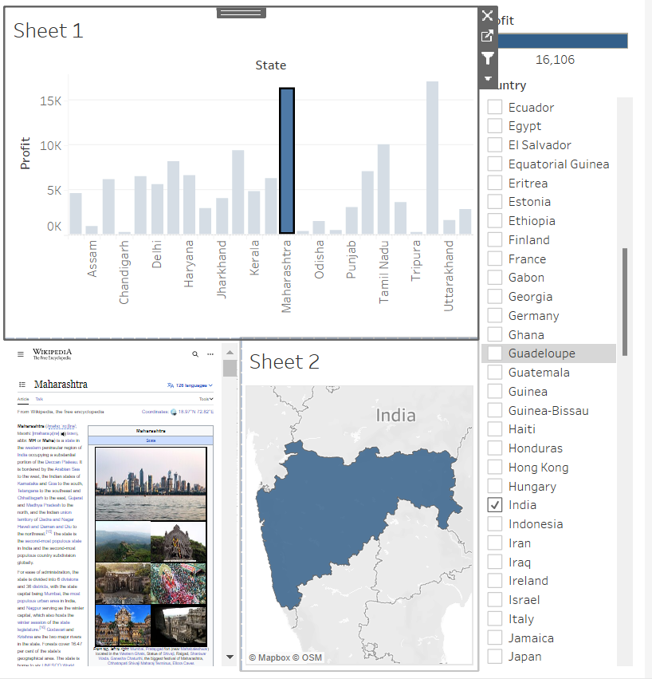

**Creating dashboard using Tableau**